Tuning of PID Parameters

The performance of a PID controller is totally depends on the three parameters: proportional coefficient (Kp), integral coefficient (Ki), and the differential coefficients (Kd). I tried a P controller at first, that is, I set Kd and Ki to zero. Then, I tried a PD controller followed by a PID controller. After tuning these parameters, I got the following results:

* A P controller is not stable. It always oscillates. Larger parameter Kp can lead to quicker response. However, the oscillation is also heavier. Smaller gain lead to slower response. Because the response is too slow, the vehicle also oscillates heavily.
* A PD controller can be stable. Generally, more the differential coefficient Kd, more stable the vehicle has. However, we cannot set too large Kd because of at least two reasons: one is the response will be too slow, the other is the actuator will saturate very quickly.
* A PID controller is useful in our case because there is a bias between the actual steering angle and the setting. When I set the steering angle to 0, the actual steering angle was not 0; it was 0.44. A PID controller can eliminate steady state errors. I know the parameter Ki cannot be too high. If the parameter Ki is too high, the controller will become very unstable. I tried Ki from 0.1, then 0.01, then 0.001.

I tried parameter combinations as below:

|  |  |  |  |  |  |  |  |  |  |  |  |
| --- | --- | --- | --- | --- | --- | --- | --- | --- | --- | --- | --- |
| No. | 1 | 2 | 3 | 4 | 5 | 6 | 7 | 8 | 9 | 10 | 11 |
| Kp | 1 | 2 | 0.5 | 0.5 | 0.5 | 0.25 | 0.25 | 0.25 | 0.25 | 0.25 | 0.20 |
| Ki | 0 | 0 | 0 | 0 | 0 | 0 | 0.1 | 0.01 | 0.001 | 0.001 | 0.001 |
| Kd | 0 | 0 | 0 | 1 | 2 | 2 | 2 | 2 | 2 | 3 | 3 |

The simulations results are listed as following figures.

The first parameters are (Kp,Ki,Kd)=(1,0,0)

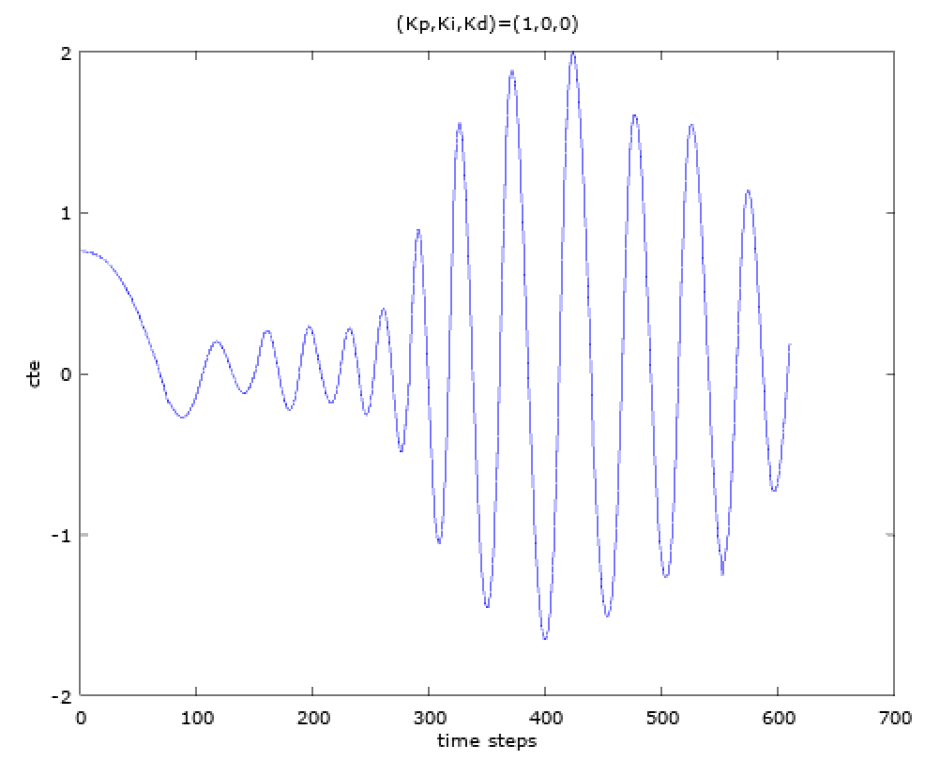

The vehicle oscillates. Especially, after time step 300, the vehicle enters its first turn, and the vehicle oscillates heavier.

The next parameter combination is (Kp,Ki,Kd)=(2,0,0)

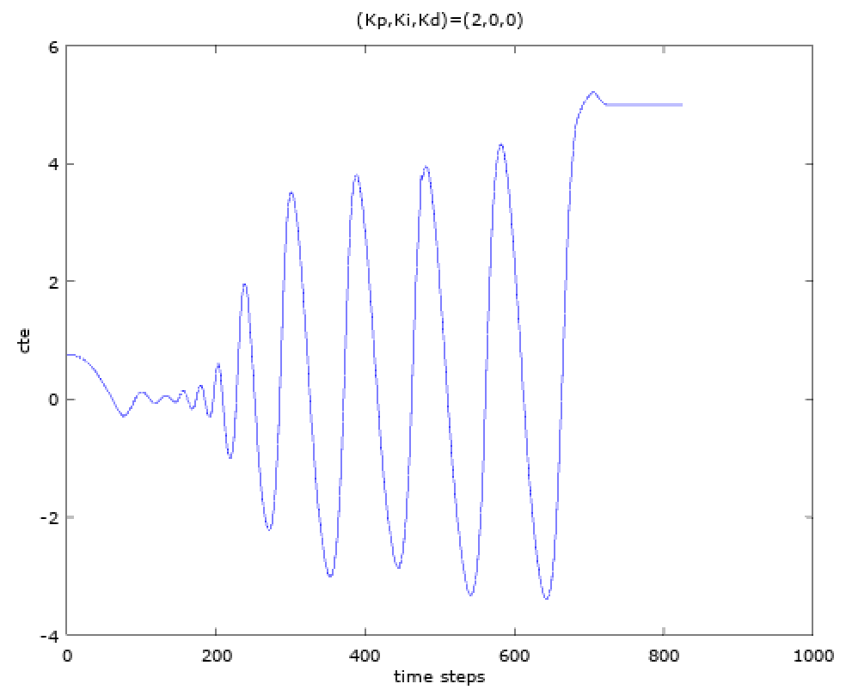

We can find that more gain got heavier oscillation.

The next parameter combination is (Kp,Ki,Kd)=(0.5,0,0)

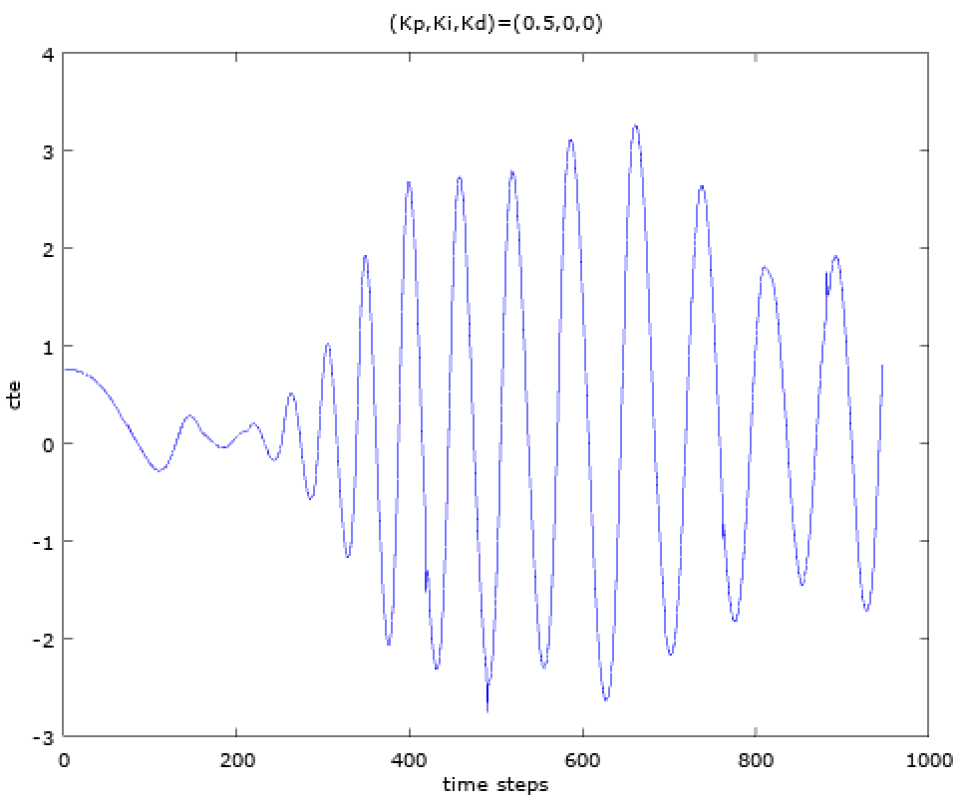

The vehicle still oscillates.

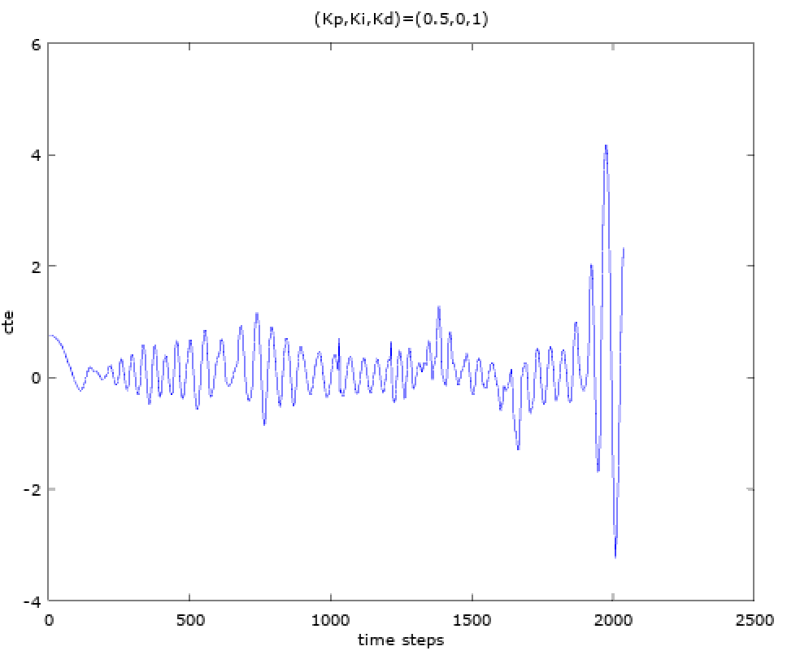

Add differential coefficient is effective. However, about time step 1800, the vehicle began oscillated. So, I want to add more Kd next time.

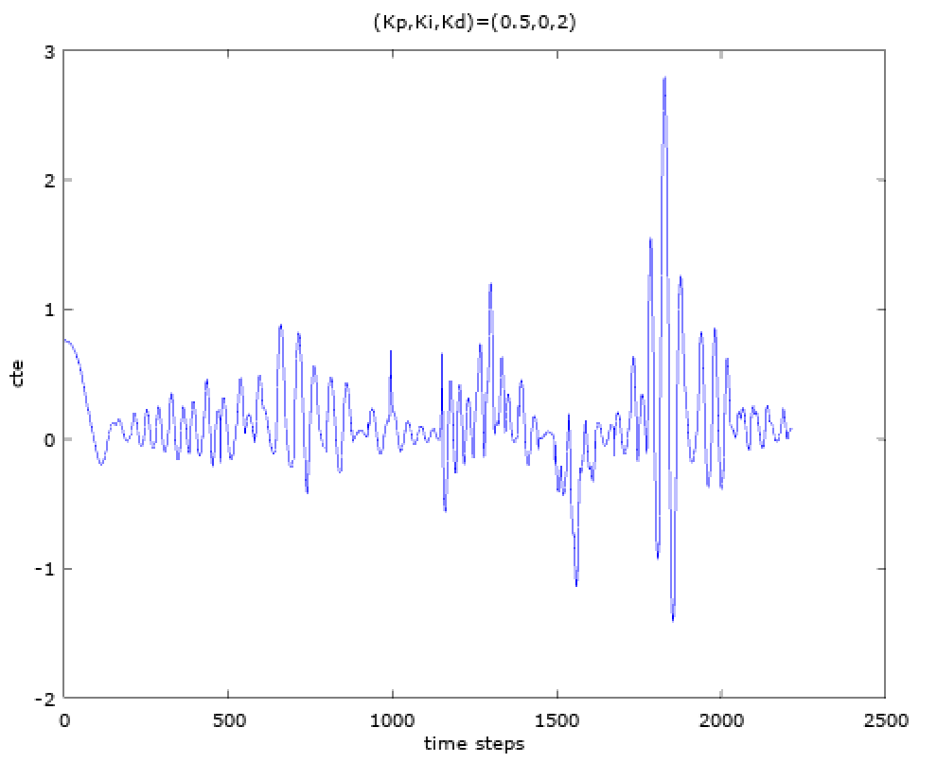

Although I added the Kd gain, the vehicle is still unstable around time step 1800. So, I guess maybe the proportional gain is too large. Next time, I will reduce the Kp gain.

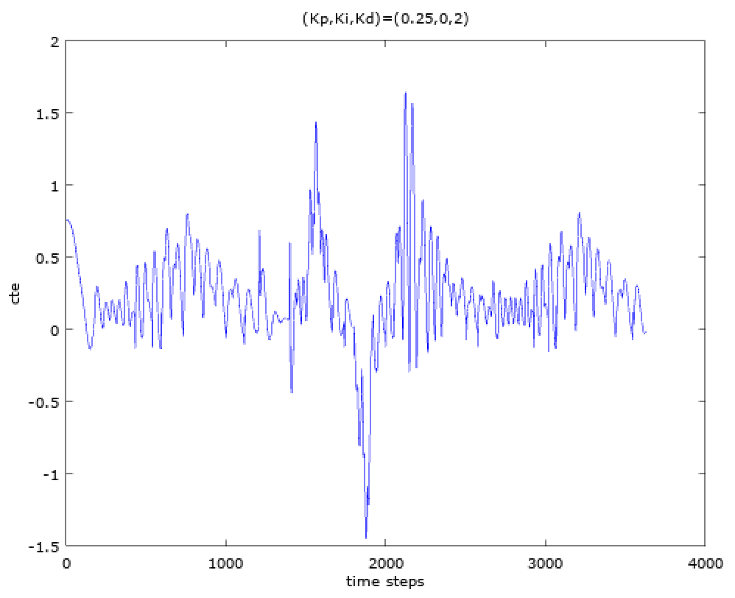

This time, the vehicle can drives itself within the lane. Next time, I will try a PID controller.

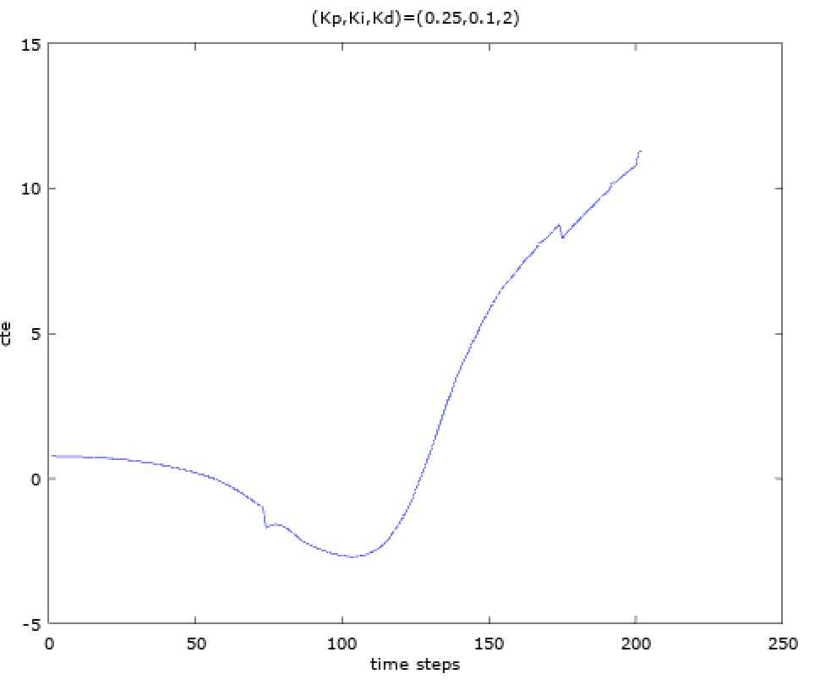

It is obvious that Ki is not a good one. I will reduce Ki next time.

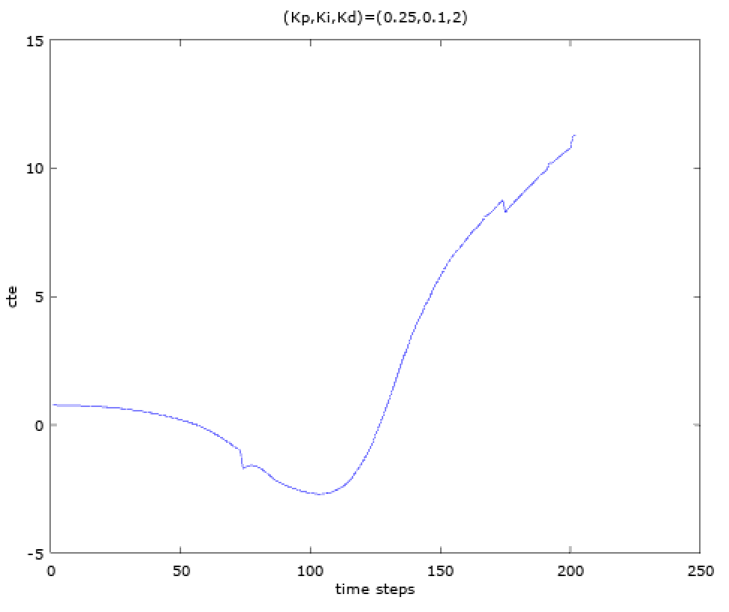

It is still unstable. I will keep reduce Ki next time.

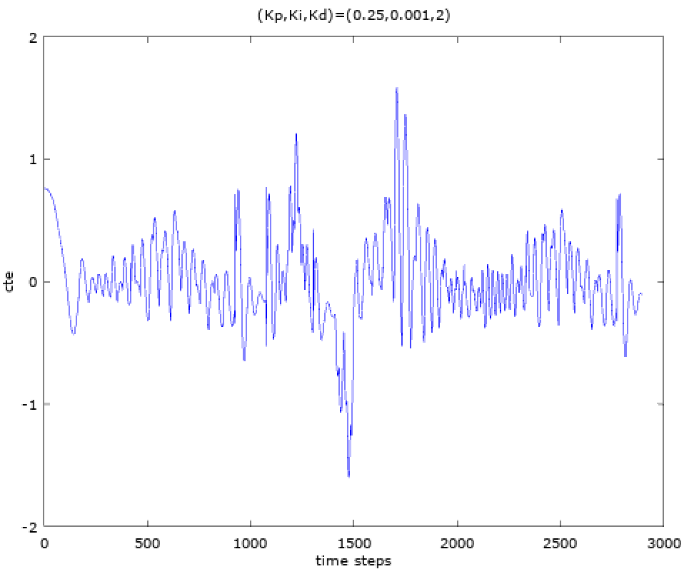

Now, the parameter combination (Kp,Ki,Kd)=(0.25,0.001,2) looks pretty good. Next time, I would like to know whether adding a little Kd can let the vehicle more stable.

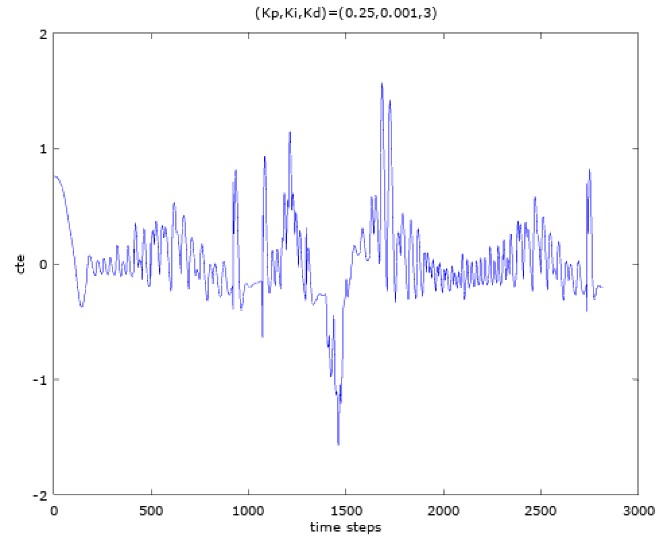

The result is very similar to the previous one. Since I have added a little Kd, I also have to reduce a little Kp. So, next time, I will reduce a little Kp.

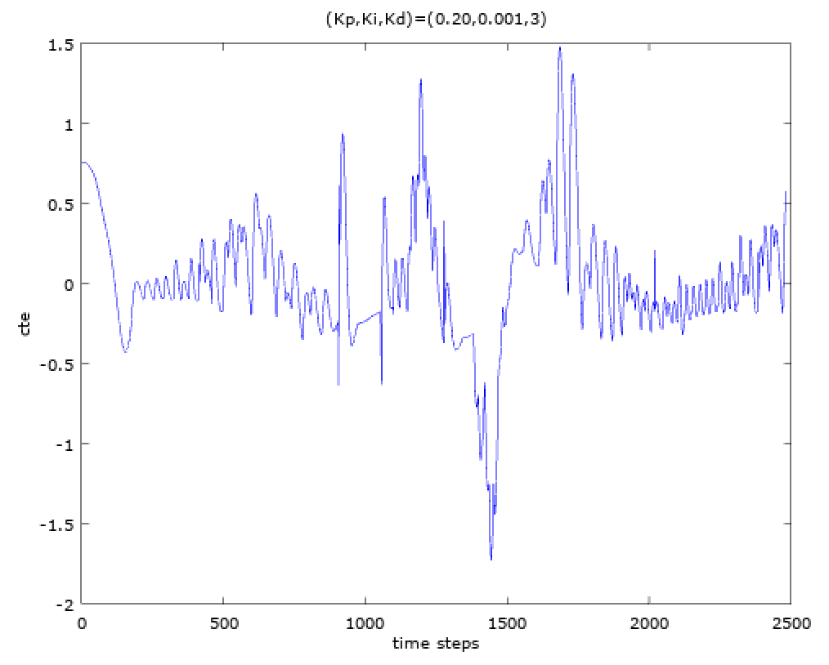

This time, it seems everything is good, I accept this parameter combination: (Kp,Ki,Kd)=(0.2,0.001,3).